1995 WHO OWNS WHOM: BOTTLED WATER

This report explores in detail the corporate ownership of all the significant companies in the bottled water segment of the multi-billion dollar beverage marketplace -- those with sales from one million to over 100 million in bottled waters. The companies are listed by size nationally and analyzed state by state, with complete data on sales volume, brands, headquarters and subsidiary facilities, chief operating personnel (with addresses and telephone numbers), number of employees-even delivery fleets-by location.

Published in 1996, this report, originally priced at $2,395, has been discounted to $1,495.

Order Report

Home

Who owns Whom
In the U.S.
Bottled Water Industry
1995 Edition
November, 1995
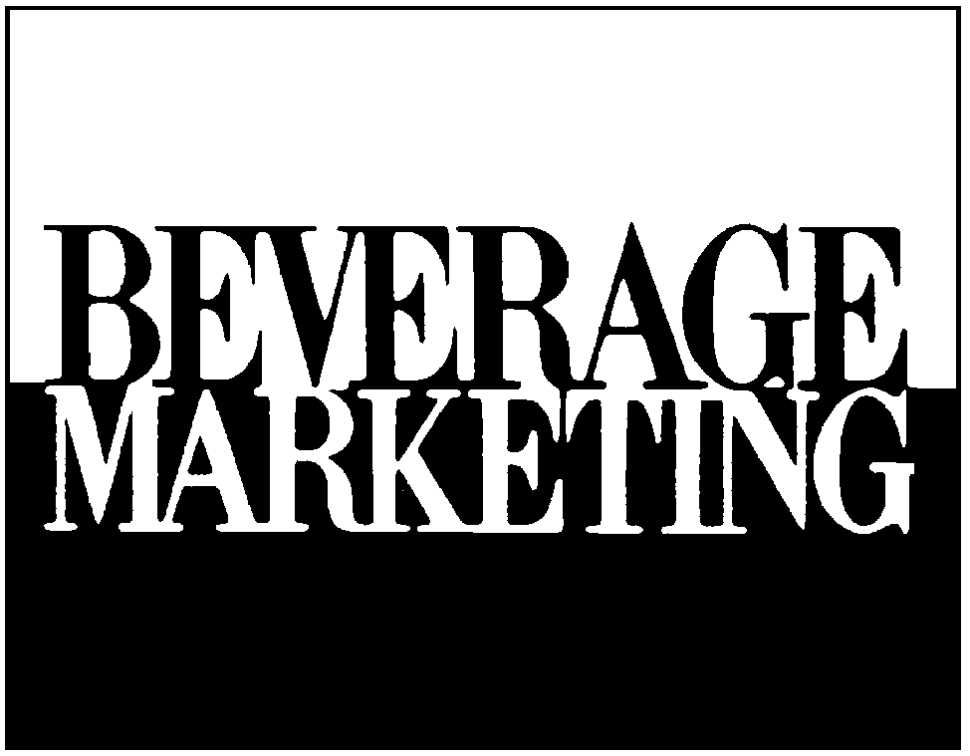
^{researchdataconsulting}
NOTE:
The information contained in this report is confidential and solely intended
for the benefit of the immediate recipient hereof.
Copyright © 1995 Beverage Marketing Corporation of New York, 850 Third Avenue, New York, New York 10022,
(212) 688-7640. All rights reserved. Reproductions in any form prohibited by law.

Table of Contents

TABLE OF CONTENTS……………………………………………………………… i

KEY CODES/RANGES……………………………………………………………….. ii

I. U.S. BOTTLED WATER HEADQUARTERS/SUBSIDIARY PROFILES
Part 1 - Over $100,000,000 Headquarters Companies 1
Part 2 - $50 to $100,000,000 Headquarters Companies 9
Part 3 - $25 to $50,000,000 Headquarters Companies……………………. 10 Part 4 - $10 to $25,000,000 Headquarters Companies……………………. 15 Part 5 - $5 to $10,000,000 Headquarters Companies……………………... 22
Part 6 - $3 to $5,000,000 Headquarters Companies………………………. 28
Part 7 - $2 to $3,000,000 Headquarters Companies………………………. 32
Part 8 - $1 to $2,000,000 Headquarters Companies………………………. 35
Part 9 - Under $1,000,000 Headquarters Companies……………………... 39

- HEADQUARTERS INDEX – NATIONAL LISTING……………………… 47

III. HEADQUARTERS INDEX – STATE LISTING…………………………… 49

IV. SUBSIDIARY INDEX………………………………………………………… 51

- SELECTED BOTTLED WATER FRANCHISE SYSTEM LISTINGS
- Apollinaris………………………………………………………………. 60
- Artesia…………………………………………………………………… 61
- Asante’…………………………………………………………………... 63
- Calistoga………………………………………………………………… 65
- Cold Spring……………………………………………………………… 78
- Contrexeville……………………………………………………………. 80
- Crystal Geyser…………………………………………………………... 81
- Evian…………………………………………………………………….. 92
- Koala Springs……………………………………………………………. 130
- La Croix…………………………………………………………………. 133
- Mendocino Mineral Water………………………………………………. 147
- Mountain Valley………………………………………………………… 148
- Naya……………………………………………………………………... 165
- Perrier……………………………………………………………………. 181
- Poland Spring……………………………………………………………. 216
- Ramlosa………………………………………………………………….. 228
- San Pellegrino……………………………………………………………. 234
- Saratoga…………………………………………………………………... 247
- Syfo………………………………………………………………………. 254
- Vichy Celestins…………………………………………………………… 255
- Vittel……………………………………………………………………… 256

KEY CODES AND RANGES

BRAND CODES
Alhambra………………………………….. ALH
Arrowhead Puritas………………………… A/P
Artesia……………………………………... ART
Black Mountain……………………………. B/M
Calistoga…………………………………… CAL
Crystal Bottled……………………………... C/B
Crystal Water…………….………………… C/W
Deer Park…………………………………… C/P
Great Bear………………………………….. G/B
Hinckley & Schmitt………………………… H&S
Kentwood…………………………….…….. KEN
Mountain Valley……………………………. M/V
Oasis………………………………………… OAS
Ozarka………………………………………. OZA
Poland Springs……………………………… P/S
Polar Water………………………………….. P/W
Saratoga……………………………………... SAR
Silver Spring………………………………… S/S
Sparkletts……………………………………. SPA
Syfo…………………………………………. SYF
Apollinaris………………………………….. APP
Contrexeville…………………………….…. CON
Evian………………………………………… EVI
Perrier……………………………….…….… PER
Ramlosa……………………………….……. RAM
San Pellegrino………………………………. S/P
Vichy Celestins……………………………… V/C

DELIVERY TRUCK RANGES
1 to 4
5 to 9
10 to 19
20 to 29
30 to 39
40 to 49
50 to 74
75 to 99
100 or more

BOTTLER SALES RANGES
$200,000,000 or More
$150,000,000 to 199,999,999
$100,000,000 to 149,999,999
$75,000,000 to 99,999,999
$50,000,000 to 74,999,999
$40,000,000 to 49,999,999
$30,000,000 to 39,999,999
$25,000,000 to 29,999,999
$20,000,000 to 24,999,999
$15,000,000 to 19,999,999
$10,000,000 to 14,999,999
$5,000,000 to 9,999,999
$3,000,000 to 4,999,999
$2,000,000 to 2,999,999
$1,000,000 to 1,999,999
$500,000 to 999,999
Under $500,000

EMPLOYEE RANGES
1 to 4
5 to 9
10 to 19
20 to 29
30 to 39
40 to 49
50 to 74
75 to 99
100 or More

